CLG MEETING –
MARCH 2020

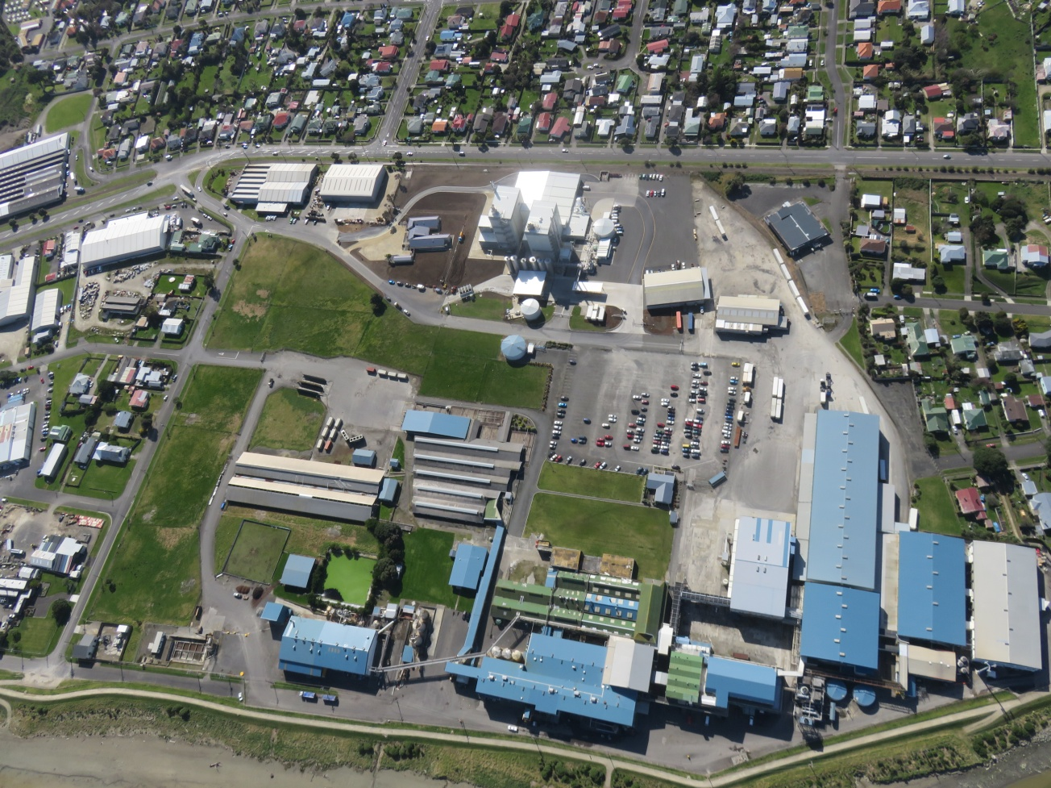

TABLE OF CONTENTS
- Minutes of Last Meeting.
- Current Odour Complaint Register.
- Current Odour Complaint Trends.

1. Minutes of Last Meeting.
AFFCO IMLAY
COMMUNITY LIAISON GROUP MEETING – AUGUST 2019

Date of Meeting: 28.08.19

Present: David Berry (Imlay Plant Manager); Ricky Gowan (Imlay Compliance Manager); Wayne McFerrier (Imlay Rendering Supervisor); Pita Kinaston (Horizons); Caleb Smith (Horizons); Graham Pearson; John & Auriel Lawson; Ruth Tidemann.

Apologies : Mr & Mrs Harris; Val Bristol ; Carol & Peter Henderson ; Barbara Allan ; Stephen Bryson.
ACTIONS AGREED:
Subject | Action
Topics of Discussion and Agreed Actions | Meeting Agenda:- Introductions; Company Action Plan update; Previous Meeting Action Points Update; Odour Complaint Register for current monitoring period.  Introductions:-  Wayne McFerrier – Imlay Rendering Supervisor:- Background in Military and Police. Has experience in Rendering. Previously was Rendering Supervisor at a Fish Rendering Plant in the South Island. Wayne is a ‘trouble-shooter’ who is determined to ensure Imlay’s Rendering Plant meets Resource Consent conditions.  Caleb Smith – Horizons:- Caleb is based in Whanganui and will be responsible for monitoring AFFCO Imlay’s consent compliance.  Action Point Updates:-  Company Action Plan:-  - Ducting of outside raw bin (Target Date:- 29.03.19). Completed April 2019.  - Capping of Rendering plant roof (Target Date:- 05.04.19). Completed April 2019.  - Re-commissioning of air intake units (Target Date:- 05.04.19). Completed April 2019.  - Installation of a blood processing system at AFFCO Manawatu (Target Date:- mid 2020). Manawatu blood now trucked to another Rendering Plant.  Meeting Action Points:-  - Need to check odour phone message and change to make user friendly. Completed March 2019.  - Follow-up on stand-alone bio filter for outside raw bin (engineers notes). Engineers Notes included in CLG Meeting Handout – August Meeting.  - Publish ‘Company Action Plan’ in local newspapers. Email sent to all meeting attendees (March Meeting).  - Check affco website for ease of access. Completed March 2019. No issues.  - Issue preventative maintenance plan for the rendering plant (minimise mechanical breakdowns). Preventative Maintenance Plan included in email to meeting attendees (March Meeting).  Discussion Points:-  A significant amount of money has been invested in the Rendering Plant over the last 2 months. New screw conveyors have been installed. Bio Filters are targeted to be replenished. Kupe Ltd independent report issues / potential solutions with associated target dates tabled.  AFFCO Imlay Management is well aware that the investments made, coupled with raw material quality and good manufacturing further processing, will be put to the test this pending summer / peak processing season.  Next CLG Meeting set for March 2020.  Meeting closed 18:00. Thanks to all those who attended.

2. Current Odour Complaint Register.
Nº | NAME | ADDRESS | DATE | TIME | COMMENTS | Substantiated | Unsubstantiated
1 | Iona Soulsby | 1a Kings Ave | 02.05.19 | 13:50 | Terrible rotten smell coming from Imlay. Smells like dead animals | ✓
2 | Horizons (John Gleeson) | 53 Balgownie Ave | 02.05.19 | 14:25 | Odour reported to Horizons. Horizons performed a FIDOL Assessment. Horizons reported to AFFCO Imlay at 16:26 (Pita Kinaston contacted Ricky Gowan) | ✓
3 | Horizons (John Gleeson) | 36 Matipo Street | 26.07.19 | 13:45 | Odour reported to Horizons. Reported as a 4. Imlay Rep / Horizons Rep / Armourguard met at complainants address. Smell not coming from Imlay. Biscuit cooking smell. |  | ✓
4 | Horizons (Christina Mott) | 6 Saunders Place | 04.10.19 | 14:45 | Odour reported to Horizons. Resident from Saunders Place stated that there was an odour coming from Imlay at 14:45. |  | ✓
5 | Horizons (Christina Mott) | 53 Balgownie Ave | 31.10.19 | 14:40 | Odour reported to Horizons. Carol Henderson stated that there was a cooking odour coming from Imlay at approx. 14:35. |  | ✓
6 | Mr & Mrs Lawson | 16a Bignell Street | 28.11.19 | 18:15 | Odour reported to Imlay at 17:30 stating that the odour was a rotten meat or offal or effluent smell. | ✓
7 | Mr & Mrs Lawson | 16a Bignell Street | 29.11.19 | 14:40 | Odour reported to Imlay at 14:40. Not a good odour coming from Imlay. |  | ✓
8 | Mr & Mrs Lawson | 16a Bignell Street | 29.11.19 | 18:25 | Odour reported to Imlay at 18:25. Cooked offal odour. |  | ✓
9 | Stephen Bryson | 7 Saunders Place | 11.12.19 | 19:50 | Odour reported to Imlay at 19:50. |  | ✓
10 | Dianne Atkinson | N/A | 12.12.19 | 9:30 | Odour detected while walking dog up and down Beach Road. |  | ✓
11 | Lonia Sarniak | 7 Saunders Place | 24.12.19 | 14:12 | Odour coming from Imlay. Can smell it inside the house. |  | ✓
12 | Pat Marsh | 10 Balgownie Ave | 10.01.20 | 13:50 | Odour coming from Imlay. Sheep wool / sheep shit smell. |  | ✓
13 | Tony (Pat Marsh) | 10 Balgownie Ave | 13.01.20 | 11:47 | Odour coming from Imlay. Really bad before the rains came. |  | ✓
14 | Sandi Black | 71 Bignell Street | 17.01.20 | 16:22 | Odour coming from Imlay. |  | ✓
15 | Johanna O'Lerell (Visitor) | 1a Kings Ave | 18.03.20 | 17:50 | Dead smell coming from Imlay |  | ✓

3. Current Odour Complaint Trends.

Compliance Period | 07 - 08 | 08 - 09 | 09 - 10 | 10 - 11 | 11 - 12 | 12 - 13 | 13 - 14 | 14 - 15 | 15 - 16 | 16 - 17 | 17 - 18 | 18 - 19 | 19 - 20
Substantiated | 55 | 9 | 10 | 3 | 0 | 1 | 1 | 29 | 6 | 4 | 5 | 39 | 3
Total Complaints | 89 | 20 | 20 | 11 | 0 | 2 | 2 | 37 | 8 | 11 | 18 | 65 | 15

Points of Interest:-
1. Significant improvement made in this current ‘Compliance Period’ compared to the 2018 – 2019 ‘Compliance Period’.
2. Nil substantiated complaints YTD for ‘high risk’ months (January / February / March).
3. First time since the ‘2011 – 2012 Compliance Period’ we have had nil substantiated complaints for the ‘high risk’ months.
4. Lowest substantiated number of complaints since the 2013 – 2014 Compliance Period.

Contributing Factors:-
1. Fresher ‘Raw Material’ which is processed expeditiously.
2. Fewer mechanical breakdowns.
3. Improved cleaning regime overseen by the Rendering Supervisor:- Application of enzyme based cleaner ‘BioZyme’ on machinery in the wetside of the Rendering Plant.

