|  |
| --- |
| **CLG MEETING – MARCH 2024**  **ODOUR PERFORMANCE REVIEW** |

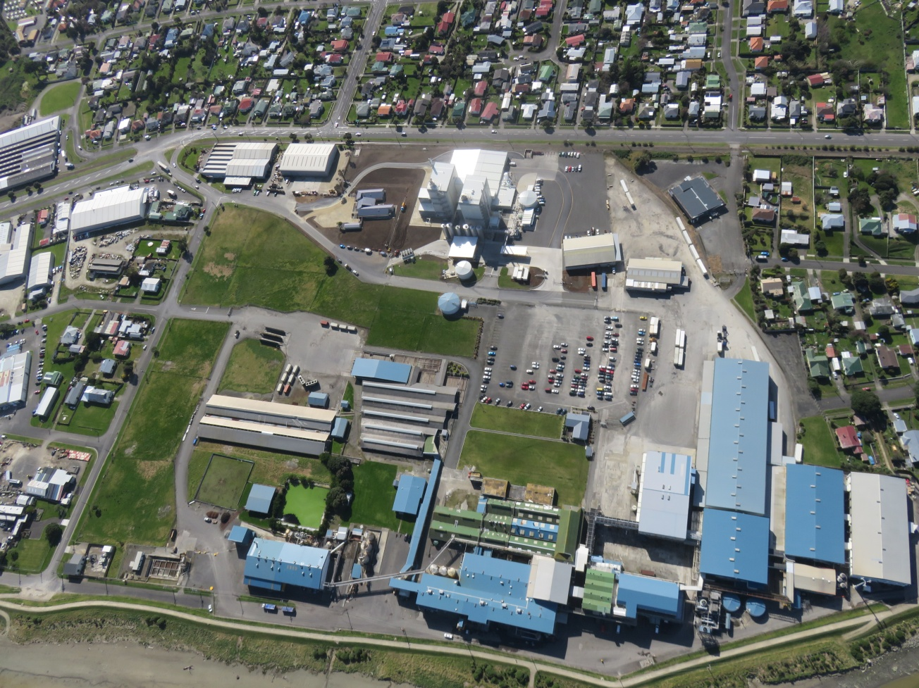

**TABLE OF CONTENTS**

1. **2023 CLG Meeting Minutes.**
2. **Current Odour Complaint Trends.**
3. **Odour Complaint Register.**

**1. 2023 CLG Meeting Minutes**

|  |  |
| --- | --- |
| AFFCO IMLAY  **COMMUNITY LIAISON GROUP MEETING – MARCH 2023** | |
| Date of Meeting: 29.03.23 **Present: Walid Mahmoud - Imlay Plant Manager (WM); Ricky Gowan - Imlay Compliance Manager (RG); Barbara Allan (BA); Graham Pearson (GP) ; Pita Kinaston – Horizons (PK).**  **Apologies :-** | |
| **ACTIONS AGREED:** | |
| **Subject** | **Action** |
| Topics of Discussion and Agreed Actions | **Meeting Agenda:-**   * Review 2022 CLG Meeting Minutes; * Odour Complaint Trending; * Points of Interest; * Odour Complaint Register 2022 / 2023 period.   Minutes:-  RG:- Discussed action required from previous minutes. Monthly odour trends now displayed on AFFCO website as well as complaint reports for substantiated odour complaints. Current odour trends were tabled along with the current ‘Complaints Register’.  BA:- Stated that she found it difficult to find the content on the AFFCO website. WM showed BA the correct links to follow.  BA and GP both stated that the significant reduction in the number of odour complaints from the previous year was very pleasing (1 substantiated odour complaint in the reporting period). This was also backed up by PK. Horizons had noted a definite reduction in odour complaints via their hotline.  GP:- Commented positively on the format of the Complaints Register, in particular the detailed comments regarding FIDOL assessments and outcomes.  WM:- Commented on AFFCO’s commitment to continual improvement. Stated that the company is prepared to invest in improving odour control systems.  BA:- Commented on the pending consent renewal and what that may look like in relation to monitoring requirements. BA also touched on Open Country odour consent responsibilities.  PK explained that Open Country does have a consent to comply too.  Meeting closed 18:00. Thanks to all those who attended. |

**2. Current Odour Complaint Trends**

|  |  |  |  |  |  |  |  |
| --- | --- | --- | --- | --- | --- | --- | --- |
| **Compliance Period** | **17 - 18** | **18 - 19** | **19 - 20** | **20 - 21** | **21 - 22** | **22 - 23** | **23 - 24** |
| **Substantiated** | 5 | 39 | 3 | 1 | 24 | 1 | 1 |
| **Unsubstantiated** | 13 | 26 | 12 | 3 | 20 | 13 | 6 |
| **Total Complaints** | 18 | 65 | 15 | 4 | 44 | 14 | 7 |

**Points of Interest:**

1. 50% reduction in odour complaints compared to last reporting period.

2. Only one substantiated odour complaint in November 2023 caused by an operator error (air odour extraction system not turned on).

**3. Odour Complaint Register**

**2023 – 2024 Reporting Period:-**

|  |  |  |  |  |  |  |  |  |
| --- | --- | --- | --- | --- | --- | --- | --- | --- |
| **ODOUR COMPLAINTS REGISTER 2023 - 2024** | | | | | | | | |
| **(Period from the 1st of May 2023 to 30th of April 2024)** | | | | | | | | |
| **No** | **NAME** | **ADDRESS** | **DATE** | **TIME REPORTED** | **TIME OF INVESTIGATION** | **COMMENTS** | **SUBSTANTIATED (Ours)** | **UNSUBSTANTIATED** |
| 1 | Horizons contacted odour phone. | Complainants address not given | 27.05.22 | 16:02 | 16:25 | No address given only that the complainant was calling from the western side of the Rendering Plant. Odour unsubstantiated. |  | ✓ |
| 2 | Not known | 88 Koromiko Road | 26.07.23 | 15:04 | 15:15 | Received a phone call from a resident at 88 Koromiko Road regarding an odour complaint. Said it had been happening for days on end. Had a lengthy discussion with the complainant during the FIDOL assessment. |  | ✓ |
| 3 | Jessica Smith | 5 Gunn Street | 08.11.23 | 18:55 | 19:16 | Received a phone call on AFFCO Odour phone from Jessica Smith at 18:55 - 5 Gunn Street. She stated that odours could be detected from 15:00 onwards. Odours were rated as strong. | ✓ |  |
| 4 | Jessica Smith | 5 Gunn Street | 11.11.23 | 16:40 | 17:18 | Received a phone call on AFFCO Odour phone from Jessica Smith at 16:40 - 5 Gunn Street. She stated that odours were coming from Imlay. Armourguard detected some slight odours however the Imlay Rendering Plant was not operating. |  | ✓ |
| 5 | Iona Soulsby | 1A Kings Ave | 09.12.23 | 11:10 | 12:10 | Received a phone call on AFFCO Odour phone at 11:10 - 1A Kings Ave. Imlay Rendering Plant was not operating. Armourguard FIDOL assessment stated that it wasn't an AFFCO odour. Most likely from Open Country. |  | ✓ |
| 6 | Ronald Thomas | 33a Bignell Street | 17.01.24 | 16:16 | 18:02 | Received a call at 16:16 on the AFFCO Odour phone. Armourguard contacted immediately but were on a call out hence the delay in the time the odour complaint was investigated. Odours were described as 'aged offal' |  | ✓ |
| 7 | Reuben Davis | 51 Balgownie Ave | 07.02.24 | 17:30 | 21:24 | Received a call from Horizons at 20:50 regarding an odour complaint lodged at 20:28 from a resident at 51 Balgownie Ave. Odour described as 'burnt bones'. Armourguard contacted. Armourguard FIDOL assessment stated that it wasn't an AFFCO odour at the time of their assessment. This was also backed up by Imlays FIDOL investigation. Conclusion is that the odour was coming from industries west of the Plant. Odour unsubstantiated. |  | ✓ |