|  |
| --- |
| **CLG MEETING – MARCH 2023**  **ODOUR PERFORMANCE REVIEW** |

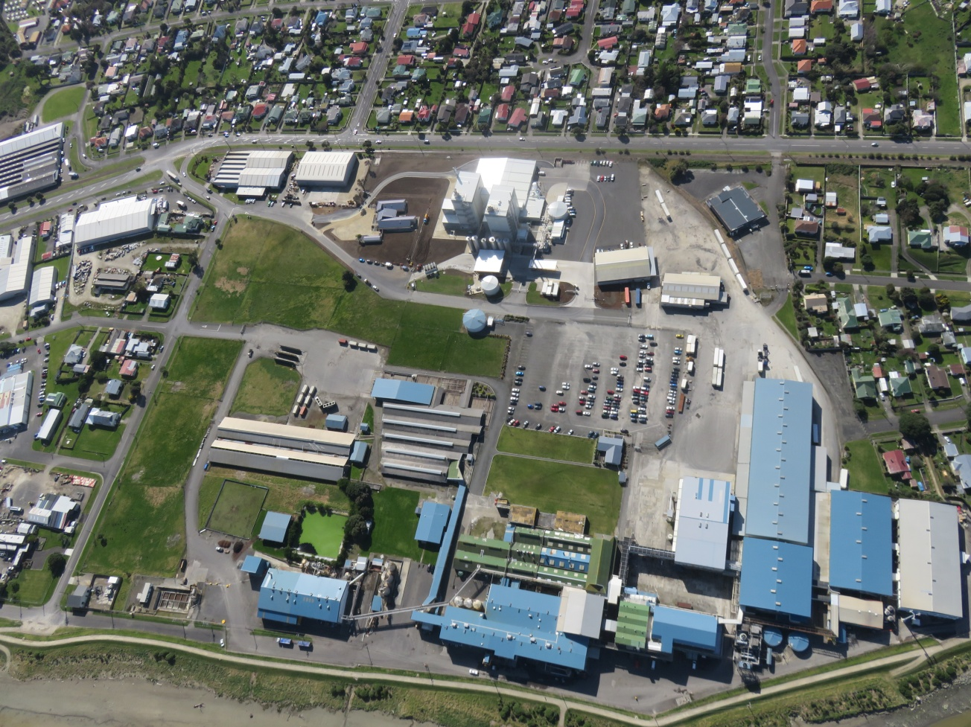

**TABLE OF CONTENTS**

1. **2022 CLG Meeting Minutes.**
2. **Current Odour Complaint Trends.**
3. **Odour Complaint Register.**

**1. 2022 CLG Meeting Minutes**

|  |  |
| --- | --- |
| AFFCO IMLAY  **COMMUNITY LIAISON GROUP MEETING – MARCH 2022** | |
| Date of Meeting: 29.03.22 **Present: Chris Bruns (AFFCO Environmental Manager); Dean Tucker (AFFCO Operations Manager); Walid Mahmoud (Imlay Plant Manager); Ricky Gowan (Imlay Compliance Manager); Oriana Van Nistelrooy (Horizons); Caleb Smith (Horizons); Gemma Bishop (WSP); Barbara Allan; Graham Pearson; Peter Firth; Sandra Kyle.**  **Apologies :- Pita Kinaston (Horizons); Valarie Bristol; Hayden Turoa (WDC); Emily Mason; Peter Firth (arrived and left prior to start of meeting).** | |
| **ACTIONS AGREED:** | |
| **Subject** | **Action** |
| Topics of Discussion and Agreed Actions | **Meeting Agenda:-**   * CLG Meeting Odour Performance Review; * 2021 CLG Meeting Minutes; * Current Odour Complaint Trends and Proposed Corrective Actions; * Rendering Plant Upgrades and Proposed Changes; * Odour Compliant Register; * RenderTech Action List.   Minutes:-  **RG:-** Tabled Odour Performance Review document and discussed content:-   * 2 actions required from the 2021 CLG Meeting closed out; * trending odours for the current reporting period; * contributing factors for the increase in odour complaints:- Manawatu floods; numerous mechanical breakdowns, Taranaki Byproducts fire at xmas 2021 and subsequent processing of raw material from Alliance, SSF – Hawera, ANZCO – Eltham; * Proposed corrective actions going into the new reporting period:- appointment of fulltime fitter in Rendering Plant – preventative maintenance; addressing visible fuming within the Rendering Plant; external audits of extraction systems by specialist consultants; diverting raw product that is out of spec; ensuring raw material is a fresh as possible; performing 3rd party audits of raw product suppliers. * RenderTech Action List:- current status.   **DT:-** Covered proposed changes in regard to the Blood Processing Plant, the blood drying process and the effect that it may have on odours. Stated the upgrades would improve the discharge of odour through improved point source extraction and also processing times would be reduced through increased capacity. Stated that AFFCO is committed to continual improvement in relation to odour producing activities at the Imlay site.  **GB:-**  Discussed Odour Impact Assessment Report prepared by Golders for the proposed changes to the Blood Processing Plant and less than minor conclusion in relation to air quality effects. Proposed changes to the Blood Plant would likely be processed as a variation to the existing consent. |

|  |  |
| --- | --- |
| **ACTIONS AGREED:** | |
| **Subject** | **Action** |
| Topics of Discussion and Agreed Actions | **BA:-** Stated that AFFCO is on notice in relation to objectionable odours. Sad to think that the good work done last year has been undermined by this year’s events; Would like to see monthly odour trends displayed on the AFFCO website as well as complaint reporting for substantiated odour complaints (RG to action). Also questioned how well Horotiu’s blood drying plant performs in relation to generating odours.  **DT:-** Responded that there had been minimal complaints relating to the blood drying process at Horotiu. It was also explained that Imlay would only take on extra blood, in excess of that already received from Manawatu and Castlecliff, if there was a breakdown at the Horotiu Plant and that this had been assessed within the Odour Impact Assessment Report also.  **CS:-**  Described Horizons relationship with Imlay and that over the years, subsequent to current issues, that there been a noted improvement in relation to objectionable odours beyond the boundary fence. There is a good working relationship between both parties.  **WM:-** Commented that since the introduction of a fulltime maintenance fitter that there had been a drop in the number of odour complaints made:- March versus January / February.  In summary, AFFCO Imlay management is committed to ensuring compliance and maintaining a good relationship with surrounding neighbours. AFFCO Imlay management is also focused on ensuring only ‘fit for purpose’ raw product is processed – fresh is best.  Meeting closed 18:45 |

**2. Current Odour Complaint Trends**

|  |  |  |  |  |  |  |
| --- | --- | --- | --- | --- | --- | --- |
| **Compliance Period** | **17 - 18** | **18 - 19** | **19 - 20** | **20 – 21** | **21 - 22** | **22 - 23** |
| **Substantiated** | 5 | 39 | 3 | 1 | 24 | 1 |
| **Unsubstantiated** | 13 | 26 | 12 | 3 | 20 | 13 |
| **Total Complaints** | 18 | 65 | 15 | 3 | 45 | 14 |

**Points of Interest:**

1. Significant reduction in odour complaints for current period.

2. The quality of raw product has improved due to Taranaki By-products back in production.

3. Only one substantiated odour complaint in May of last year caused by a mechanical breakdown and poor communication with trucking companies.

**3. Odour Complaint Register**

**2022 – 2023 Reporting Period**

|  |  |  |  |  |  |  |  |  |
| --- | --- | --- | --- | --- | --- | --- | --- | --- |
| **ODOUR COMPLAINTS REGISTER 2022 - 2023** | | | | | | | | |
| **(Period from the 1st of May 2022 to 30th of April 2023)** | | | | | | | | |
| **No** | **NAME** | **ADDRESS** | **DATE** | **TIME REPORTED** | **TIME OF INVESTIGATION** | **COMMENTS** | **SUBSTANTIATED (Ours)** | **UNSUBSTANTIATED** |
| 1 | Horizons contacted odour phone. | Complainants address not given | 27.05.22 | 16:02 | 16:25 | No address given only that the complainant was calling from the western side of the Rendering Plant. Odour unsubstantiated. |  | ✓ |
| 2 | Horizons contacted odour phone. | Complaint made from Airport | 31.05.22 | 15:39 | 16:00 | Plant breakdown 30.05.22. Horizons informed. Production commenced following day at approx. 14:00. Back log of raw product in outside raw bin caused odours. | ✓ |  |
| 3 | Lonia Soniak via Horizons. | 7a Saunders Place | 23.09.22 | 15:55 | 16:00 | Horizons contacted Imlay Odour phone at 15:55 for a complaint lodged at 15:00. Character of smell was rated as a sickly sweet smell which indicates an Open Country odour (RG has discussed the difference between Imlay and Open Country odours in the past with Lonia). Imlay FIDOL assessment resulted in no odours coming from Rendering Plant. |  | ✓ |
| 4 | Horizons (James Dobson) contacted Compliance Manager | 186 Heads Road | 19.11.22 | 17:57 | 19:35 | Horizons contacted Compliance Manager at 19:13 on Saturday the 19th of November. Horizons official - James Dobson - stated that he was at the address (186 Heads Road) but could not detect any odours beyond the boundary fence. Compliance Manager contacted Armourguard requesting a FIDOL investigation to take place. The FIDOL assessment outcome was unsubstantiated - no odours detected. |  | ✓ |
| 5 | Not known | 186 Heads Road | 22.11.22 | 21:20 | 21:25 | FIDOL assessments carried out by Armourguards Kristi Townsend and Night Shift Production Supervisor - Greg Stanley. No odours detected. |  | ✓ |
| 6 | Trevor Beamsley | 292 Heads Road | 28.01.23 | 20:50 | 21:15 | Complainant stated that there was a burning smell coming from Imlay at 20:50. Rendering Plant not operating at that time. On site investigation and off-site investigation both unsubstantiated. NOTE:- There is a business in Leamington Street responsible for this odour. |  | ✓ |

|  |  |  |  |  |  |  |  |  |
| --- | --- | --- | --- | --- | --- | --- | --- | --- |
| **No** | **NAME** | **ADDRESS** | **DATE** | **TIME REPORTED** | **TIME OF INVESTIGATION** | **COMMENTS** | **SUBSTANTIATED (Ours)** | **UNSUBSTANTIATED** |
| 7 | Brent Caudwell | 18 Caius Ave | 01.02.23 | 19:51 | 19:54 | Complainant stated that there was a cooking smell odour. Investigated by Night Shift Production Supervisor - Greg Stanley - within the boundary fence. Greg could detect odours at the boundary fence and rated it objectionable if it occurred on a regular basis. Armourguard rep Kristi Townsend visited the complainants address at 18 Caius Ave and could not detect any odours. Due to fact that the FIDOL assessment is rated on objectionable odours beyond the boundary fence this complaint is rated as unsubstantiated. |  | ✓ |
| 8 | Mrs Lawson | 16a Bignell Street | 02.02.23 | 16:10 | 16:33 | Complainant stated that there was a cooking smell odour. Investigated by Night Shift Production Supervisor - Greg Stanley - within the boundary fence. Greg could not detect odours at the boundary fence and rated the complaint unsubstantiated. Armourguard rep Wayne Watson visited the complainants address at 16a Bignell Street and could not detect any odours. Wayne stated that he walked up and down the street covering around 10 houses and could not detect any odours. |  | ✓ |
| 9 | Mr Lawson | 16a Bignell Street | 09.02.23 | 20:09 | 20:15 | Complainant left message on the answer phone. Investigated by Night Shift Production Supervisor - Greg Stanley - within the boundary fence. The wind direction at the time of the FIDOL assessment was in the opposite direction from the complainants address. Greg positioned himself at the boundary fence and could detect a slight cooking odour which he rated as not objectionable. Armourguard rep Marc Casey visited the complainants address at 16a Bignell Street and could detect an odour but rated it as not objectionable. Given that the wind direction at the time of the complaint was not in the direction of the complainants house, this complaint is rated unsubstantiated. |  | ✓ |
| 10 | Horizons contacted odour phone. | Heads Road | 11.02.23 | 16:30 | 17:30 | Horizons rep arrived on site at 17:30 and spoke to the Imlay Security Guard about an odour complaint received at 16:30 from a resident in Heads Road. Imlay Security Guard explained to the Horizons rep that the Rendering Plant was not operating and had ceased operating at midday. No odours were detected and the Horizons rep left the site. |  | ✓ |

|  |  |  |  |  |  |  |  |  |
| --- | --- | --- | --- | --- | --- | --- | --- | --- |
| **No** | **NAME** | **ADDRESS** | **DATE** | **TIME REPORTED** | **TIME OF INVESTIGATION** | **COMMENTS** | **SUBSTANTIATED (Ours)** | **UNSUBSTANTIATED** |
| 11 | Joyce Billington | 41a Swiss Ave | 27.02.23 | 20:55 | 21:10 | Complainant stated that the odour 'smelt like yards'. Night Shift Production Supervisor - Greg Stanley - positioned himself at the boundary fence and could detect a slight rendering odour at times (NOTE:- Wind direction not in the direction of the complainants address). Armourguard rep - Kristi Townsend - went to the address at 21:10 and could not detect any odours. This complaint is rated as unsubstantiated due to no odours detected beyond the boundary fence. |  | ✓ |
| 12 | Not known | Gunn Street | 15.03.23 | 16:17 | 16:45 | Odour complaint received on odour phone at 16:17. Stated odour coming from Imlay. Imlay Plant Manager - Walid Mahmoud - went to Gunn Street at 16:30 .No odour detected. Armourguard Rep - Kristi Townsend - arrived at Gunn Street at 16:45 and could not detected any odours. This complaint is rated as unsubstantiated due to no odours detected beyond the boundary fence. |  | ✓ |
| 13 | Mr Lawson | 16a Bignell Street | 15.03.23 | 17:55 | 18:08 | Odour complaint received on odour phone at 17:55. Mr Lawson stated to Alan Broughton - Imlay Security Guard - that there was an odour coming from Imlay. Alan contacted Armourguard to advise them of the complaint. Armourguard Rep - Marc Casey - arrived at the complainants address at 18:08. Pockets of odour were detected but were not deemed an AFFCO smell. Marc described the smell as “possible Tasman Tanning smell – very faint”. This complaint is rated as unsubstantiated. |  | ✓ |
| 14 | Jessica Smith | 5 Gunn Street | 23.03.23 | 14:40 | 14:49 | Odour complaint received by AFFCO Imlay at 14:40. Jessica stated that there was a smell coming from Imlay. The odour complaint was investigated by Ricky Gowan - Imlay Compliance Manager and Wayne Watson - Armourguard. Pockets of very weak odour were detected for short periods of time. The source of odour was difficult to pin point. Sources could have been Imlay, Open Country, WDC Pump Station, Tasman Tanning. This complaint is deemed unsubstantiated due to odours not being objectionable beyond the boundary fence. |  | ✓ |